


AI IMAGE CLASSIFIER AND UTILITY TOOL PROJECT (VITHARTHI)

REPORT
2025–26
Advanced AI Image Classifier and editor which classifies and edit the image which we upload using Python, Streamlit, and MobileNetV2.
Submitted By: Manan Sharma
B.Tech CSE (Core)
Registration Number: 25BCE11179
VIT Bhopal

-Introduction-
This project is a simple and practical image-based tool that combines AI image classification with basic image editing utilities. It allows users to upload an image and instantly get predictions along with details like dominant color, brightness, contrast, and sharpness. Users can also resize, compress, rotate, and flip the uploaded image and can download it.
This project is an AI-powered Image Classifier built using Streamlit and MobileNetV2, a deep-learning model trained on the ImageNet dataset. It is a user-friendly web application. The core of the system is the MobileNetV2 deep learning model, which is pre-trained on the ImageNet dataset and capable of identifying thousands of objects.
The system lets users upload common image formats (JPG, JPEG, PNG) upto 200 mb and automatically classify them by ai predictions, the app presents the predicted object labels along with confidence scores.
Beyond classification, the application can do several image-analysis tasks such as identifying the image’s dominant color, brightness level, sharpness, contrast, and aspect ratio. It also have some editing tools like image resizing, compression, rotation, and flip operations. Users can view processed images and download them directly from the interface.
This makes the project not just a classifier but a complete image analysis and basic image-editing tool. Which is suitable and easy to use for beginners, students.

-Problem Statement-
Most users need separate tools for classification, resizing, compression, and basic image edits. However, most tools are either difficult to use or require installation, or only focus on one task. This project provides an easy, browser-based solution that uses AI to classify images and classify the properties, and offer simple editing features all in at one place.

-Functional Requirements-
1. Image Upload
- Users can upload JPG, JPEG, or PNG images (upto 200mb).
- The uploaded image will be displayed.

2. AI Classification
- The system processes the image using MobileNetV2.
- It shows the top 3 predictions with confidence scores.
3. Image Analysis
- The system detects dominant color, brightness, sharpness, contrast, size, and aspect ratio.
4. Image Editing Tools
- Users can resize images using sliders.
- Users can compress images by selecting quality.
- Users can rotate images between 0–360°.
- Users can flip images horizontally or vertically.
5. Download Options
- Users can download the resized/compressed, rotated, and flipped images.

-Non-Functional Requirements-
Performance
- The app should load quickly and process images within a few seconds and all the UI elements should work quickly.
Usability
- The interface should be easy to use, clear, and beginner-friendly.
Reliability
- The app should work smoothly for all supported image formats without crashing and It should operate without crashes or errors during repeated use.
Compatibility
- It should run on major browsers and different devices.

Scalability
- The app should handle many users and allow easy future updates.
Security
- Uploaded images must be processed safely and not stored permanently and Only allowed file types should be accepted.
Maintainability
- Code should be clean, organized, and easy to update.
Portability
- The app should run on both local systems and cloud platforms.

- System Architecture-
The system uses Streamlit as the frontend and Python (TensorFlow + PIL) as the backend.
Users upload an image, the backend preprocesses it, MobileNetV2 predicts the content, the app shows results, and then provides simple editing tools.
THE OVER ALL ARCHITECTURE IS:
1. User Interface (Streamlit)
- Lets users upload images.
- Shows predictions, analysis, edited results.
- Provides tools for resizing, compressing, rotating, and flipping.
- Offers download buttons.
2. Application Logic (Python Backend)
- Receives the uploaded image.
- Handles preprocessing, resizing, and preparing the image for prediction.
- Coordinates image analysis and all editing operations.
- Saves processed images temporarily for download.
3. AI Model Layer (MobileNetV2)
- Pretrained on ImageNet.
- Takes an image and generates top 3 predictions with confidence scores.
4. Image Analysis Module
- Calculates dominant colour, brightness, sharpness, contrast.
- Finds dimensions and aspect ratio.
5. Image Editing Module
- Performs resizing, compression, rotation, and flipping using PIL.
- Returns processed images back to the interface.
6. File Handling
- Stores edited images.
- Prepares them for user downloads.
Overall Flow
Upload → Preprocess → Predict → Show Results → Utility Tools (Resize, Compress, Rotate, Flip).

Design Diagrams
Use Case Diagram:

[User] --> (Upload Image)
(Upload Image) --> (Preprocess Image)
(Preprocess Image) --> (AI Prediction)
(AI Prediction) --> (Display Results)
┌───────────────┐
│ User │
└───────┬───────┘

┌────────────▼─────────────┐
│ (Upload Image) │
└────────────┬─────────────┘
▼
┌────────────┴─────────────┐
│ (Preprocess Image) │
└────────────┬─────────────┘
▼
┌────────────┴─────────────┐
│ (AI Prediction) │
└────────────┬─────────────┘
▼
┌────────────┴─────────────┐
│ (Display Results + AI │
│ Insights) │
└───────────────────────────┘

Workflow Diagram:

Start --> Upload --> Preprocess --> Predict --> Show Insights --> Tools (Resize/Rotate/Flip/Compress) --> End

Sequence Diagram:

User -> Streamlit: Upload Image
Streamlit -> Preprocessing: Resize/Normalize
Preprocessing -> Model: Predict
Model -> Streamlit: Results
Streamlit -> User: Display Output

-Design Decisions & Rationale-
Streamlit was chosen because it makes building web apps easy and lets users upload images and see results instantly.
MobileNetV2 was used since it’s a fast, lightweight AI model that gives accurate predictions without needing a powerful computer.
PIL and NumPy were used for image processing because they make tasks like resizing, rotating, and analyzing images simple.
Extra features like resize, rotate, flip, and compress were added to make the app more useful than just an image classifier.
The design focuses on being simple, fast, and user-friendly, so anyone can use it without technical skills.
-Implementation Details-
The app loads MobileNetV2 once at the start for faster predictions.
When the user uploads an image, the app displays it immediately.
The image is resized and preprocessed before sending it to the model for prediction.
The app then calculates dominant color, brightness, contrast, sharpness, and aspect ratio using simple image analysis.
Users can edit images using the built-in tools (resize, rotate, flip, compress), and each edited image is shown on the screen.
Edited images are saved temporarily and provided to the user through download buttons.
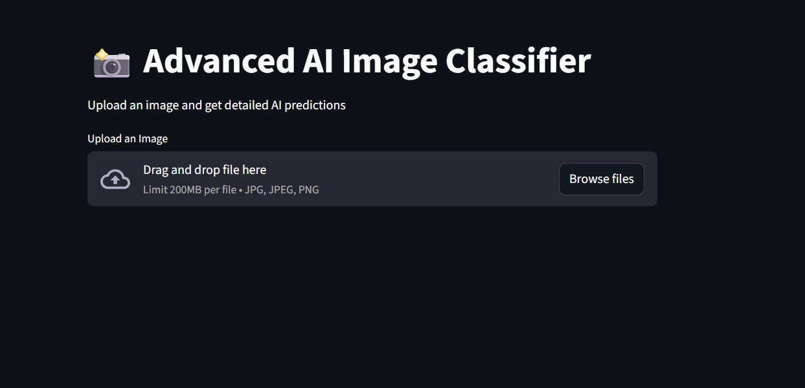
-Screenshots / Results-

1. Home Screen – Upload Section
What appears:
- Title: “📸 Advanced AI Image Classifier”
A file uploader box
A short instruction: “Upload an image and get detailed AI predictions
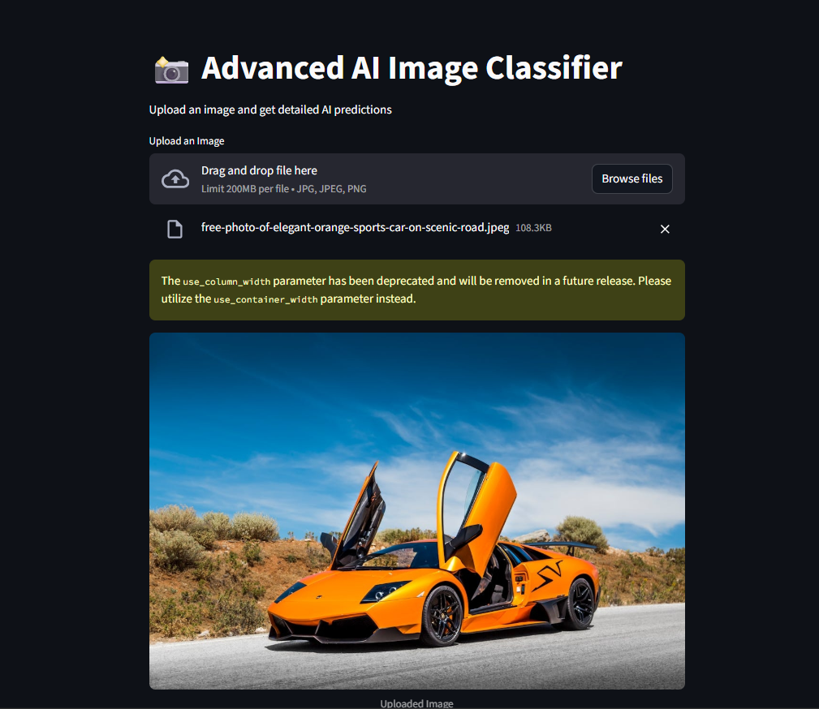
2. Uploaded Image Preview
What appears:
- The yellow racing car image appears clearly on the screen
- Caption: “Uploaded Image and by this the user confirms the correct racing car image was uploaded which Helps them see the original before editing
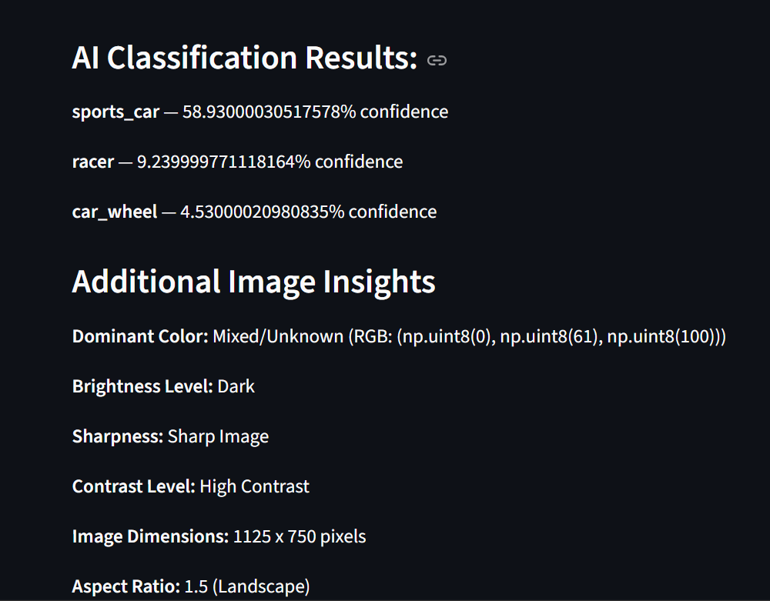
3. AI Classification Results
What the model might predict for a Yellow Racing Car:
predictions:
- sports_car — 58.93%
- racer — 9.23
- convertible — 4.53%
- Dominant Color: Yellow (RGB: around 240, 210, 60)
- Brightness:( Bright)
- Sharpness: Sharp Image
(racing car images often have clear outlines)
- Contrast: High
(yellow car contrasts strongly with road/track background)
- Image Dimensions: e.g., “1920 × 1080 pixels”
- Aspect Ratio: 1.78 → Landscape
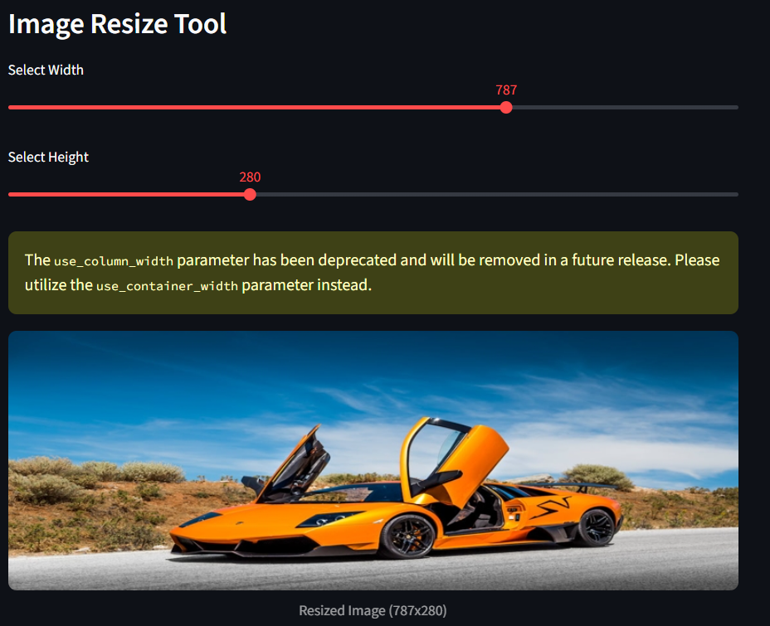
.
5. Image Resize Tool
What appears:
Two sliders:
- New Width →787 px
- New Height → e.g., 280 px
It is used to:
- To reduce size for sharing
- To crop or adjust image proportions
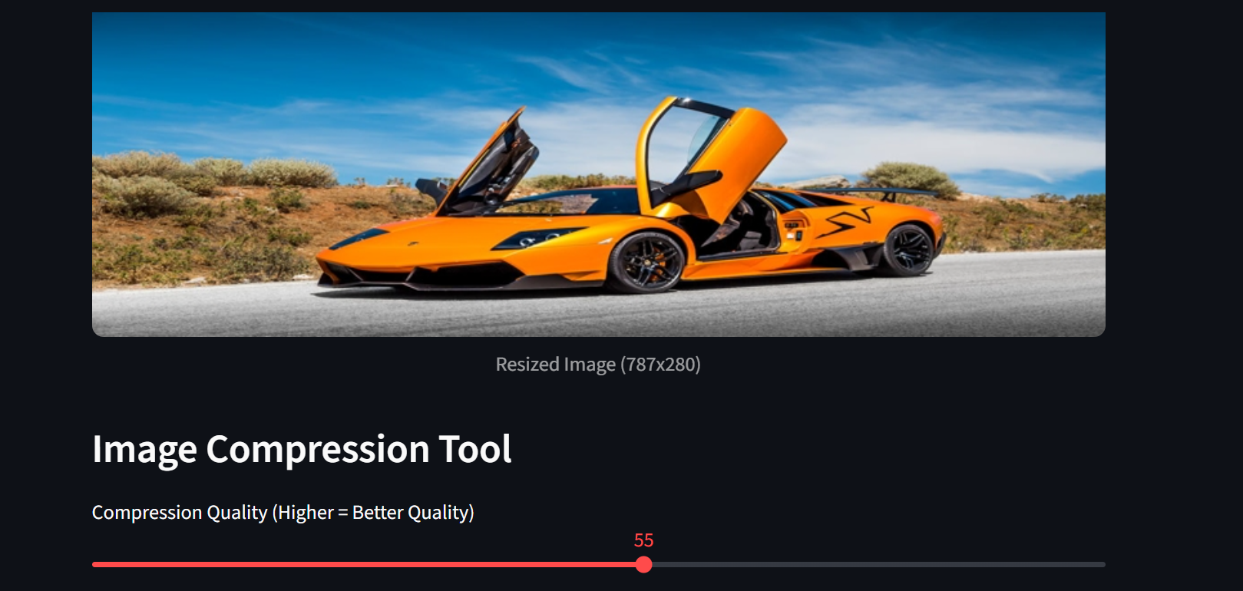
6. Image Compression Tool
What the tool shows:
- Slider for compression quality
( user selects 55%)
Compressed car image might shrink from 2.5 MB → 320 KB
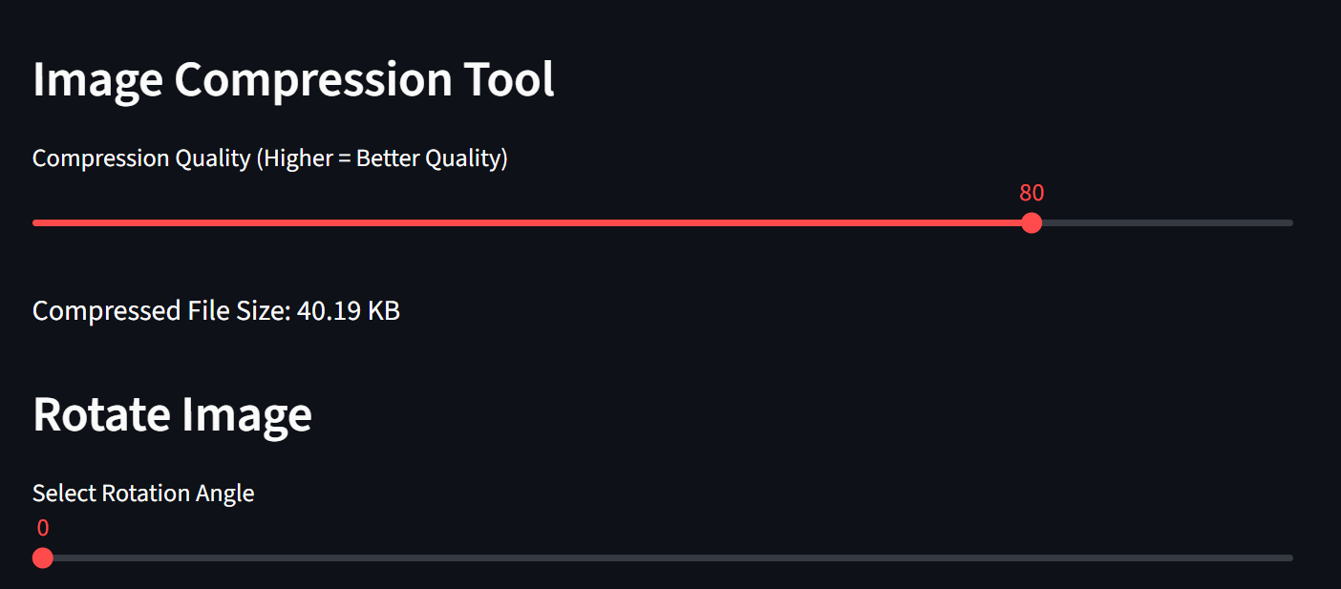
- Great for uploading racing car images on websites/social media with small size limits.
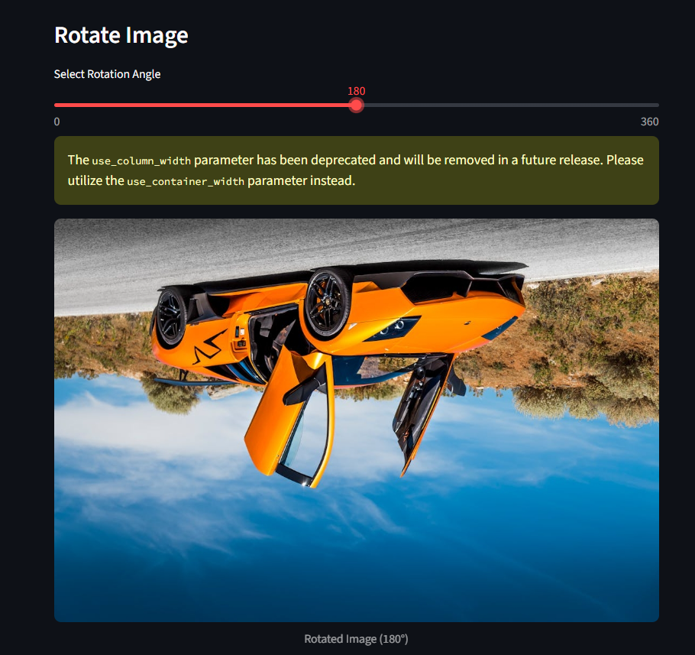

7. Rotate Image Tool:

What appears:

Slider (0° to 360°)

User rotates the yellow racing car 180°
→ The preview updates instantly.

Fix sideways images

Create artistic angles

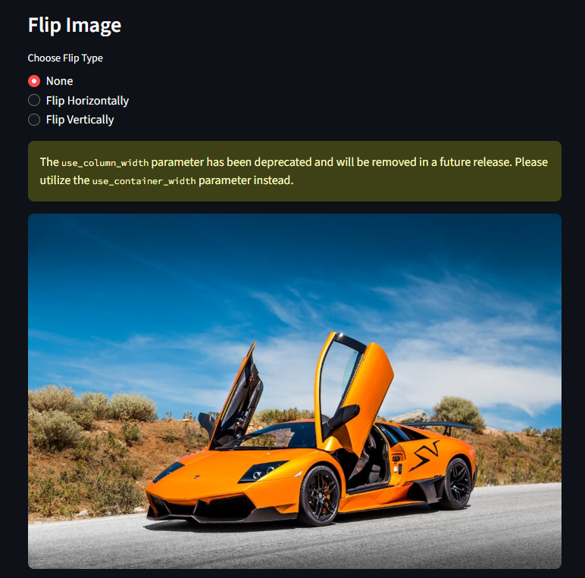
8. Flip Image Tool
Options:
- Flip Horizontally
- Flip Vertically
Flipping horizontally makes the racing car face the opposite direction.
Why helpful:
- Correct mirrored images
- Useful for design layouts
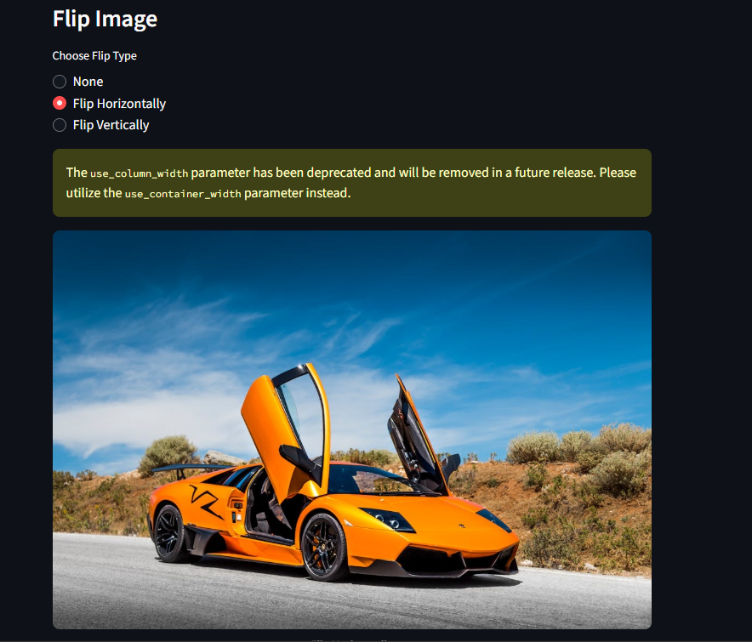

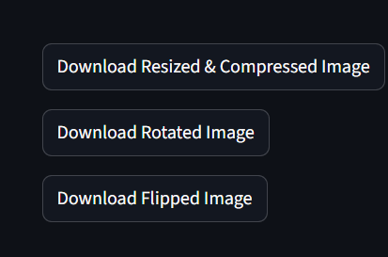
9. Download Buttons
What appears:
- Download Resized & Compressed Image
- Download Rotated Image
- Download Flipped Image
The user can download the edited yellow racing car image in different versions.

-Final Result-
After uploading the yellow racing car image, the program will show:
- The original racing car photo
- AI predictions such as “sports car”
- Insights like Yellow dominant color, Bright, High contrast, Sharp
- A resized version of the car image
- A compressed version with smaller file size
- A rotated version of the racing car
- A flipped version
- Download buttons to save all edited images
The user experiences a full image analysis + editing workflow, all from the example of a Yellow Racing Car.

-Testing Approach-
Follow these steps to test the AI Image Classifier and Editor:
1. Open the App
Launch the application in your web browser.
2. Upload an Image
Add any image file (JPG, JPEG, or PNG) to the app.
3. View Predictions & Insights
Check the AI-generated predictions along with initial image insights such as dominant color, brightness, contrast, and sharpness.
4. Try Editing Tools
Experiment with the built-in tools:
- Resizer – adjust image dimensions
- Compression – reduce file size
- Rotator – spin the image to correct orientation
- Flipper – flip horizontally or vertically
5. Download Processed File
Once satisfied with the changes, use the Download buttons to save your optimized image.

11. Challenges Faced
- Handling different image sizes
- Ensuring fast AI predictions
- Managing temporary files for downloads
- Keeping the interface simple while adding many tools
- Image Preprocessing Issues:
Some images had unusual dimensions or formats, causing errors until proper resizing and conversion steps were added.
- Model Prediction Speed:
Loading MobileNetV2 took time at first, so it was loaded only once to improve speed.
- File Handling Problems:
Saving rotated, flipped, and compressed images required careful file naming to avoid overwriting issues.
- Streamlit UI Refresh:
Some elements refreshed too often, so logic had to be simplified to keep the interface smooth.
- Color Detection Accuracy:
Getting a perfect dominant color was challenging because some images have multiple strong colors.

12. Learnings & Key Takeaways
- Practical knowledge of Streamlit
- Learned how to combine ML and simple utilities
- Better understanding of Pillow operations

13. Future Enhancements
- Better AI Models:
Add more advanced models to improve accuracy and possibly detect multiple objects in the image.
- More Editing Tools:
Introduce cropping, background removal, and image filters (blur, sharpen, grayscale) to make the app a more complete editor.
- Improved Color Detection:
Use smarter techniques such as K-means clustering for more accurate dominant color extraction.
- Multiple Image Support:
Allow users to upload and process several images at once for batch editing.
- Cloud & File Features:
Add options to save processed images to Google Drive or download all edited images together in a ZIP file.
- Better User Experience:
Provide an edit history, undo feature, and cleaner layout to make the interface more interactive and user-friendly.

-References-
- TensorFlow Docs
- Streamlit Docs
- Pillow Docs
- ImageNet Dataset
- Online blogs and guides
-Youtube

